|  |  |  |  |
| --- | --- | --- | --- |
| C:\Users\David\Dropbox\rossmoyne.png  **Reading Time**: An initial **2 minutes** to view **BOTH** sections | **MATHEMATICS METHODS : UNITS 3 & 4, 2021**  Test 2 – (10%) 3.2.1 to 3.2.22 (not 3.2.5), 3.1.1 – 3.1.6, 3.1.9 | | |
| **Time Allowed**  25 minutes | | **First Name Surname** | **Marks**  25 marks |

**Circle your Teacher’s Name:** Mrs Alvaro Mrs Bestall Ms Chua Mr Gibbon Mrs Greenaway Mr Luzuk Mrs Murray Ms Robinson Mr Tanday

|  |  |
| --- | --- |
| **Assessment Conditions: *(N.B. Sufficient working out must be shown to gain full marks)***   |  | | --- | | * Calculators: Not Allowed * Formula Sheet: Provided * Notes: Not Allowed | |

**PART A – CALCULATOR FREE**

Question 1 [2, 2, 2, 2 — 8 marks]

Differentiate the following, **do not simplify your answer**:

a) $e^{x^{2}}$ + $πcos⁡x$ b) $xe^{{sinx}^{}}$

c) $sin⁡(4x^{2}-3)$ d) $\int_{x}^{0}{{(3t^{2}-1)}^{3}dt}$ ${- 3x}^{2}$

**Question 2**

Determine the following:  **[ 2, 2, 2 — 6 marks]**

a) $\int{(x^{2}+5)^{2}dx}$ b) 

c)  given $F(x)=\int_{1}^{x}{\frac{1}{1+t^{2}}dt.}$

Question 3 [1, 1, 1, 2, 1 — 6 marks]

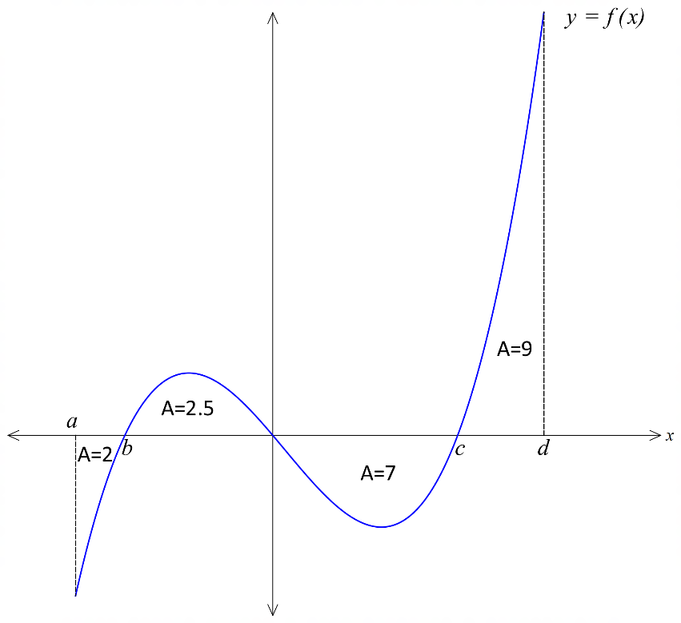The graph of  is shown below and the area of the various regions are as indicated.

Determine

a) 

b) 

c) The area enclosed between the graph of  and the *x*-axis from 

d) The value of 

e) What value of *m* gives $\int_{ 0}^{m}{f(x) dx}$ the greatest value for $x=a to x=d$.

Question 4 [1, 4— 5 marks]

a) Determine

b) Hence evaluate 

|  |  |  |  |
| --- | --- | --- | --- |
| C:\Users\David\Dropbox\rossmoyne.png  **Reading Time**: An initial **2 minutes** to view **BOTH** sections | **MATHEMATICS METHODS : UNITS 3 & 4, 2021**  Test 2 – (10%) 3.2.1 to 3.2.22 (not 3.2.5), 3.1.1 – 3.1.6, 3.1.9 | | |
| **Time Allowed**  25 minutes | | **First Name Surname** | **Marks**  25 marks |

**Circle your Teacher’s Name:** Mrs Alvaro Mrs Bestall Ms Chua Mr Gibbon Mrs Greenaway Mr Luzuk Mrs Murray Ms Robinson Mr Tanday

|  |  |
| --- | --- |
| **Assessment Conditions: *(N.B. Sufficient working out must be shown to gain full marks)***   |  | | --- | | * Calculators: Allowed * Formula Sheet: Provided * Notes: Not Allowed | |

**PART B – CALCULATOR ALLOWED**

Question 1 [3,1 — 4 marks]

The graph of the function *g(x)* is shown below. The table gives the value of the function at the given value of *x*. The rectangles drawn on the graph can be used to underestimate the area under the curve. Other rectangles could be used to overestimate the area.

|  |  |  |  |  |
| --- | --- | --- | --- | --- |
| x | 0 | 0.5 | 1 | 1.5 |
| g(x) | 9 | 10 | 12 | 15 |

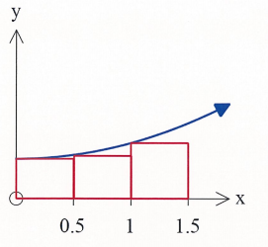

1. By considering the areas of these rectangles, show how you could estimate $\int_{0}^{1.5}{g\left(x\right) dx}$.
2. State whether your estimate above is too large or too small and suggest a modification to the numerical method employed to obtain a more accurate estimate.

Question 2 [1, 2, 2 —5 marks]

Demographers monitored a particular city’s population growth , in thousands, and found it grew according to the model , where  is the time in months from 1st January, 2010.

(a) What was the population of the city on 1st January, 2010?

By the 1st February, 2010, the population of the city increased by 250 people.

(b) Determine the value of , rounding your answer to 4 decimal places.

(c) Determine the rate of change of the population of the city on 1st January, 2011.

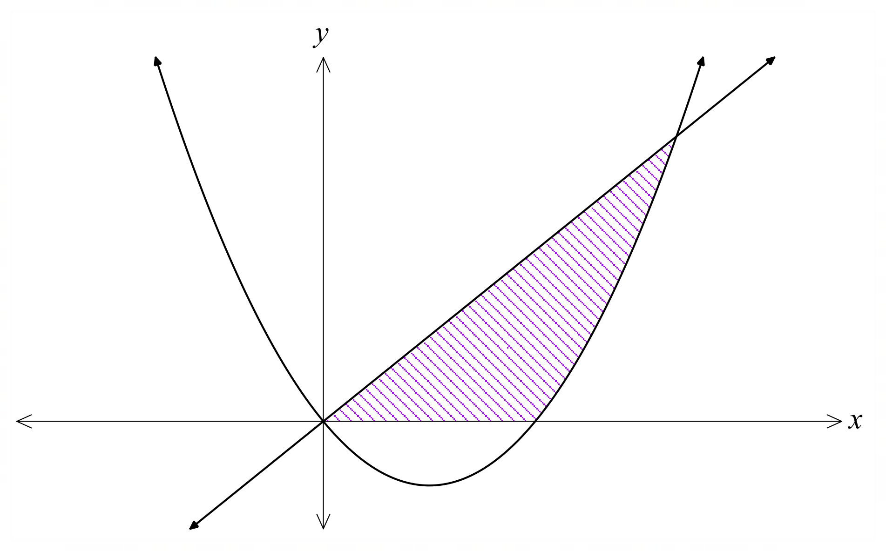Question 3 [5 marks]

The diagram shows a sketch of the curve  and the line .

Find the area of the shaded region shown.

Question 4 [2, 2, 2 — 6 marks]

A body moves along a straight line such that the velocity, at time *t* seconds, is given by $v$ metres per second where $v=2t^{2}-12t+16$.

The initial displacement of the body from the origin *O* is 4 metres.

1. Find an expression for the displacement of the particle from *O* at time *t*.
2. When is the body moving the fastest in the first 5 seconds?
3. The total distance travelled by the particle in the first 5 seconds

Question 5 [5 marks]

Let $k\left(x\right)=\int_{-1}^{x}{g(t) dt}$ with $k\left(4\right)=20$ and $\frac{d^{2}k}{dx^{2}}=2x.$

Determine the function $g(x)$.